**Experiment No:3**

**Aim**:

Familiarization of Linux Commands.

**CO2**:

Perform system administration tasks.

**Procedure**

1. pwd: print working directory

Output



1. ls: to view the contents of the directory

output

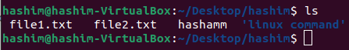

1. ls –R: list all the files in the subdirectory

Output

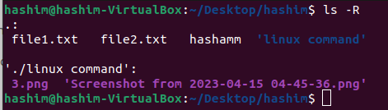

1. ls –l: long list details of the directory

Output

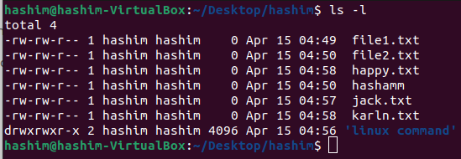

1. ls –a: to view the hidden files in the directory

Output

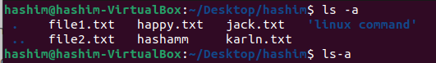

1. ls –al: list the all files including hidden files and directory with detailed information

Output

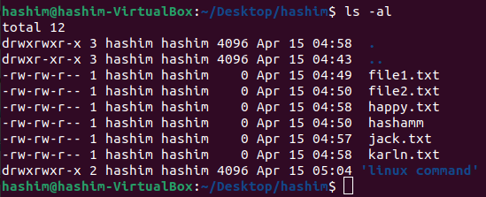

1. ls -t: to list the contents in the order of last modified.

Output



1. ls -r: to list the contents in the natural sorting order

Output

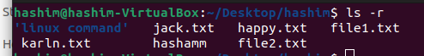

1. history: to view the history of the commands in a certain period of time.

Output

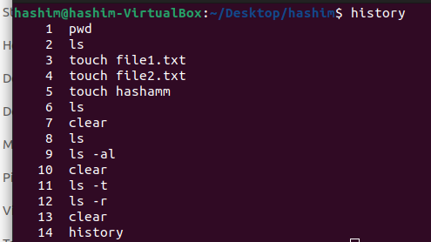

1. man ls: to list all the commands of ls. It is a supporting command

Output

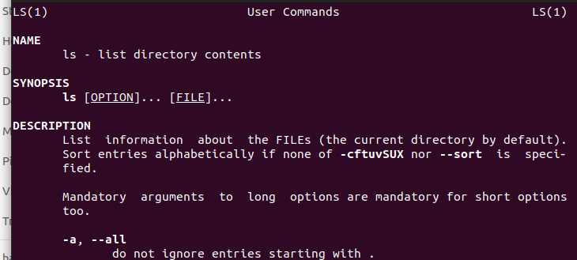

1. mkdir *directoryName* : make directory/to create new directory.

Output



1. rmdir *directoryName*: to remove the directory.

Output



1. touch: to create a new blank file.

Output

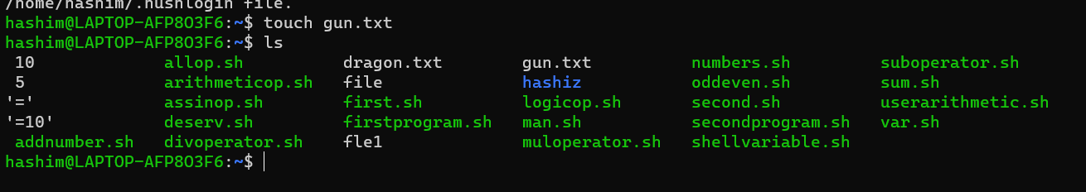

1. cat >>*filename*: to append new contents to a new or existing file.

Output

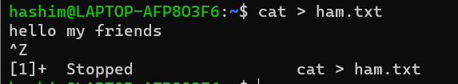

1. cat *file1 file2* > *file3*: to copy and add files from the first two files to a new file.

Output

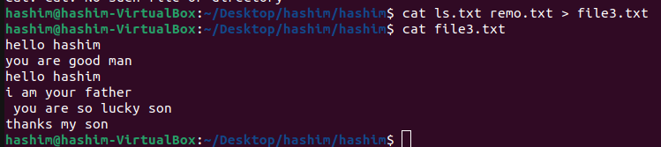

1. cat –n: to display the contents with line number.

Output

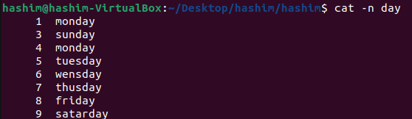

1. cat –b: to remove numbering for empty lines

Output

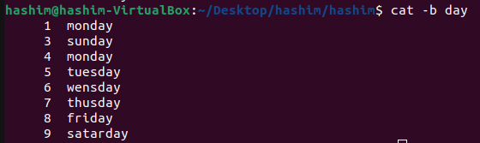

1. cat –e: to display $ character at the end of each line

Output

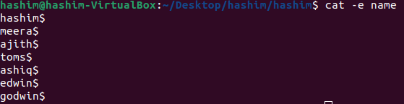

1. *filename |* tr a-z A-Z >*newfile*: to convert/ display all the contents in the capital/uppercase letters.

Output

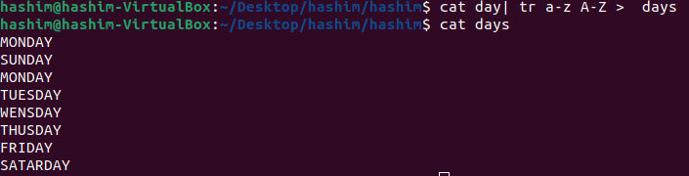

**Experiment No:4**

**Aim**:

Familiarization of Linux Commands.

**CO2**:

Perform system administration tasks.

**Procedure:**

1. cut –b1: to cut first bite letters

Output

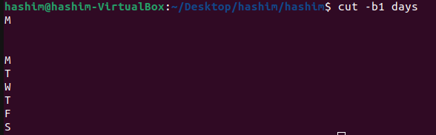

1. cut –d - -f1 filename: used d limiter to cut the contents at ‘-‘ in the first column which is given by –f1.

Output

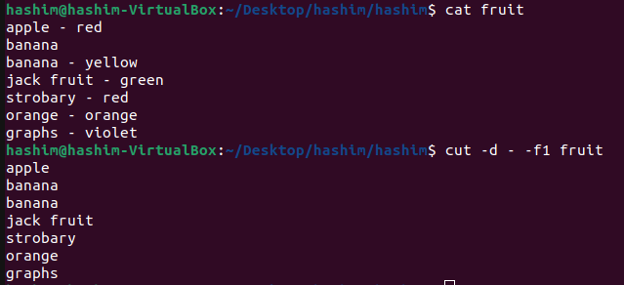

1. cut –c 1,3: to cut the letters or bites in a specified position.

Output

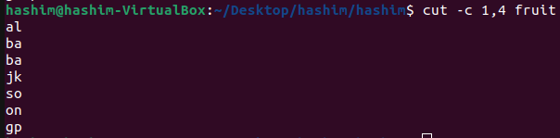

1. paste file1 file2: to paste the contents in file1 to file2.

Output

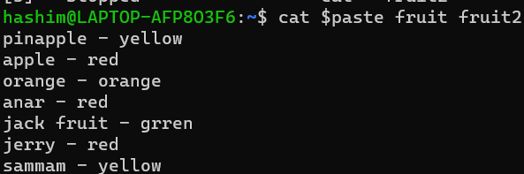

1. paste file1 file2 > file3: to paste the contents from the first 2 files to a new file.

Output

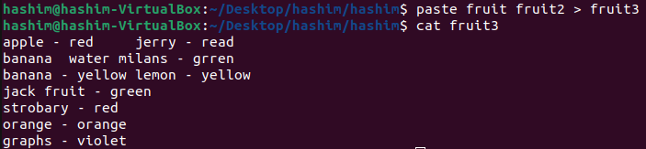

1. paste –d ‘%’ file1 file2: to paste % with delimiter in all the contents in the file.

Output

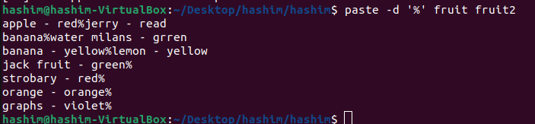

1. paste -s filename: to show all contents in a single line.

Output

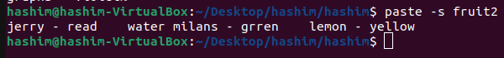

**Experiment No.: 5**

**Aim:**

Familiarization of Linux Commands.

**CO1:**

Perform system administration tasks.

**Procedure:**

1. Read: To read the content of a line. We use read comments to read lines into a variable.

To print we use -> $ echo REPLY

Output:

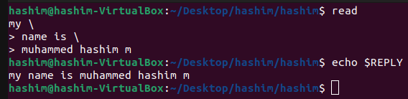

1. Read var1 var2 var3 : To store contents into variables separated by space

Output:

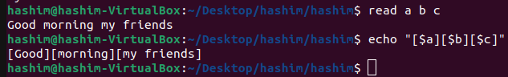

1. Read -p: to prompt text.

Output:



1. Read -n 6 -p: To enter 6 characters.

Output



1. Read -s : For security purposes.

Output:

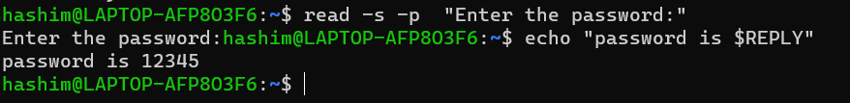

1. Wc : To count the no of lines, no of words, no of bytes.

Output:

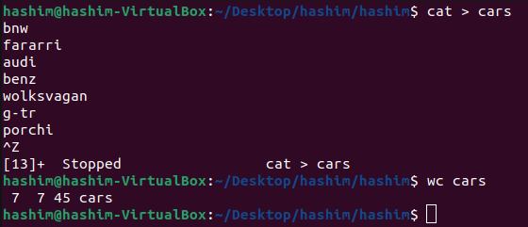

1. Wc -l: To count the no of lines.

Output:



1. Wc -w: To count the number of character

Output:



1. Wc -L: Print the length of the longest line.

Output:



1. More: similar to cut to display the content , the only difference is that in the case of a larger file.

Cat command output will scroll off your screen ,where more commands display output screen full at a time.

Output:

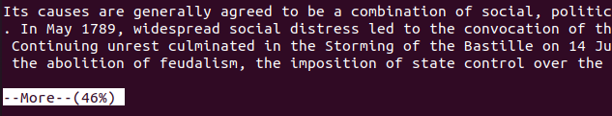

1. More +20: Display the content after the specified no of lines.

Output:

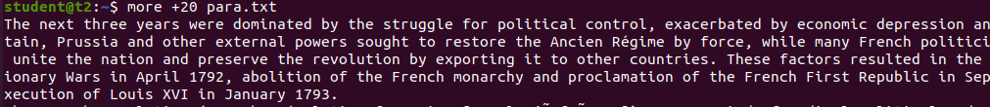

1. More -d: It helps the user to navigate according to the instructions, space to continue & q to quit.

Output:



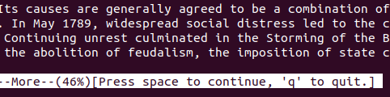

**Experiment No.: 6**

**Aim:**

Familiarization of Linux Commands.

**CO1:**

Perform system administration tasks.

**Procedure:**

1. grep : is used to filter the content to make our search easy.
2. grep -i search_content filename: Display the searched content, case insensitive search.

$grep -i English marks

output:

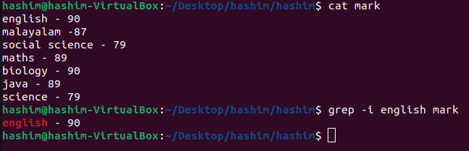

1. grep -v search_content filename: Display the contents other than the searched content.

$grep -v 56 marks

output:

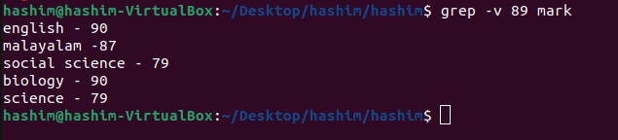

1. grep -A1 search_content filename: Display the contents of the searched line and one line after.

$grep -A1 English marks

output:

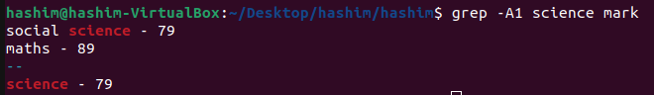

1. grep -B1 search_content filename: Display the contents of the searched line and one line before.

$grep -B1 Science marks

output:

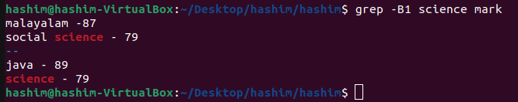

1. grep -C1 search_content filename: Display the contents of the searched line, one line before and one line after.

$grep -C1 Science marks

Output:

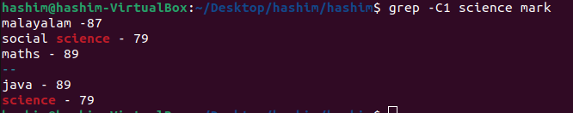

1. head filename: is used to display the top contents of the file, by default it displays the first 10 lines.

$head marks

Output:

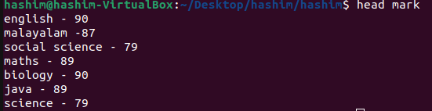

1. head -n filename : displays n lines of the file from the top.

$head -5 marks

Output:

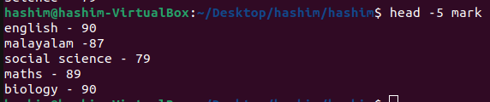

1. tail filename: displays the contents of the file from the bottom, by default it displays 10 lines.

$tail numbers

Output:

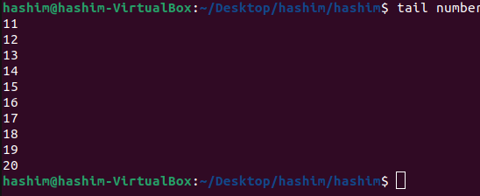

1. tail -n filename: displays n lines of the file from the bottom.

$top -5 numbers

Output:

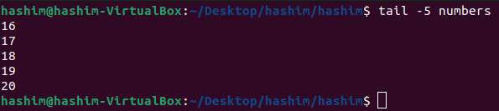

1. mv file1 file2 : moves the contents of file1 to file2 (overwrites).

$mv numbers student

Output:

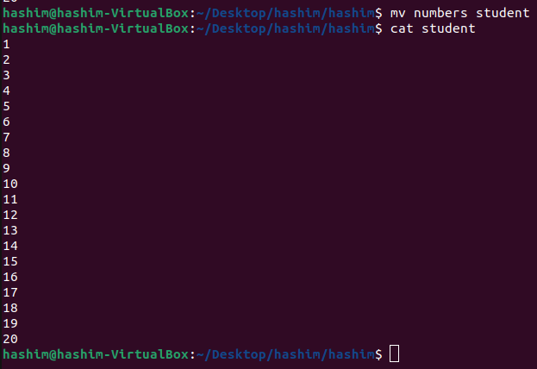

1. mv -b file1 file2 : move contents of file1 to file2 but creates a backup file for file2 with ‘~’ at the end.

$mv marks profile

Output:

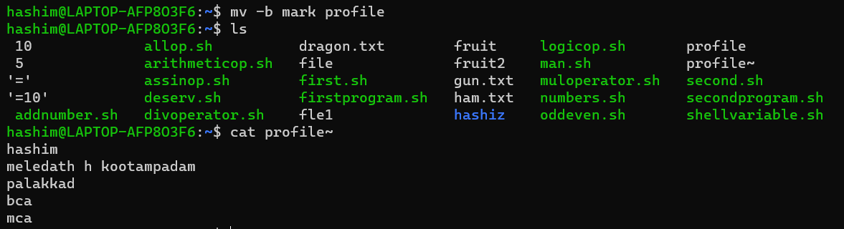

1. mv -i file1 file2 : It prompts the user whether to move the contents or not.

$mv -i profile profile2

Output:

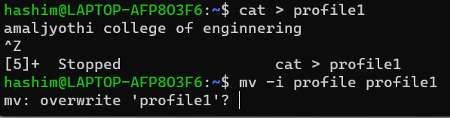

**Experiment 7**

**Aim**

**CO**

**Procedure**

expr - Evaluate expression and give output.

$expr 12 + 8

Output

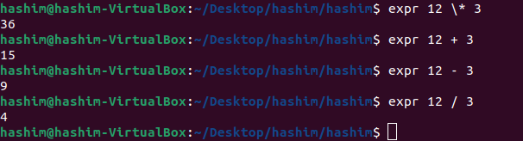

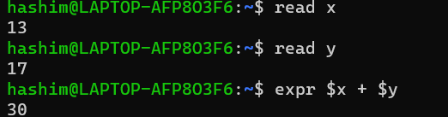

df - In terms of used space. Used to find disk utilization of the system, df is used to get a report

on disk utilization of the system.

$df

**Output**

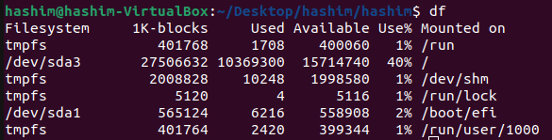

du - used to check how much file or directory takes in the current directory.

$du filename

**Output**

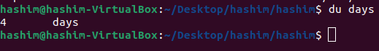

sudo

sudo jeeva



sudo passwd username

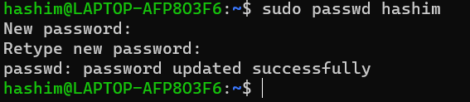

sudo groupadd



sudo usermod



id username - display group, id of the user



compgen -g : used to display all the groups.

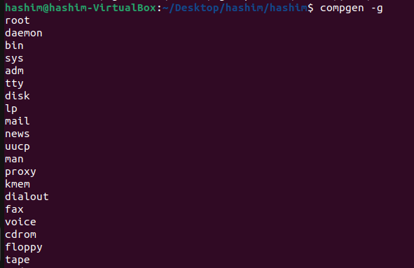

chmod : used to change the access permissions of files and directories. Its stands for change

mode.

read - r, write - w, execute - x

chmod -wx filename : deny the permissions to write and execute.

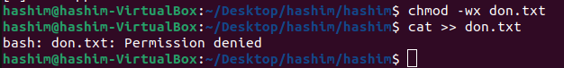

chmod +rwx filename:

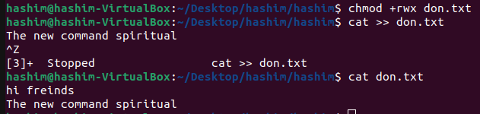

chown : is used to change a file ownership or directory ownership for a user or a group.

It stands for “change owner”.





sudo userdel username : delete the specific user.



sudo groupdel groupname: delete the specific group.

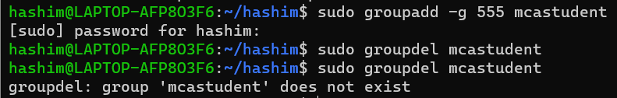

**Experiment 8**

**Aim:**

**CO:**

**Procedure:**

ssh stands for “secure shell protocol” used to securely connect to a remote server or system.

ssh is secure in the sense it transfers data in encrypted form between host and client.

connect to remote host:

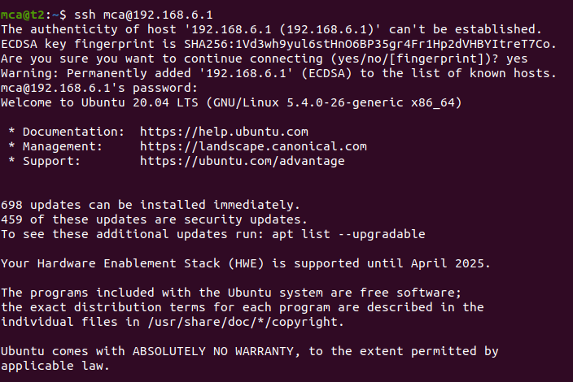

show ip address of the computer:

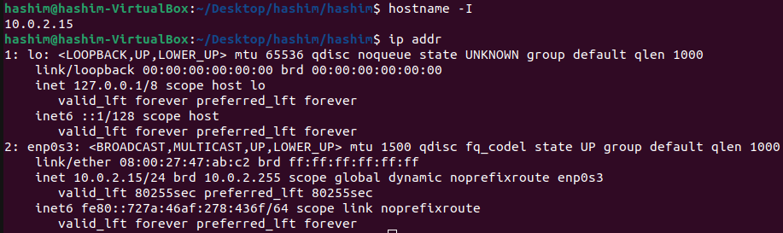

ssh-keygen:

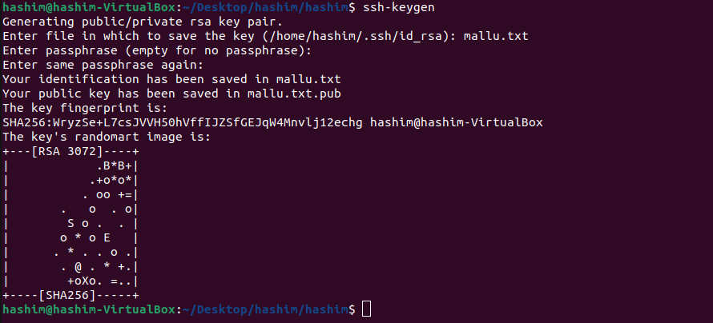

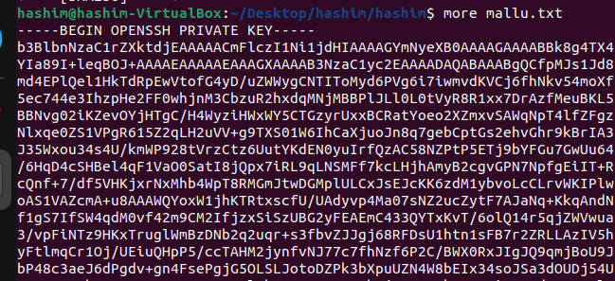

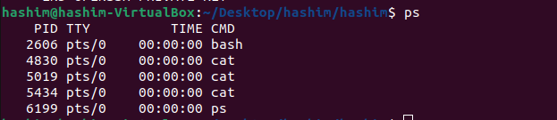

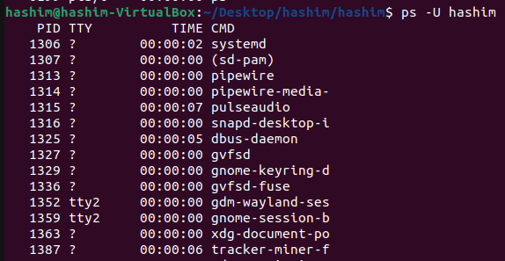

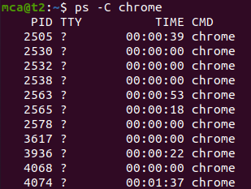



**Experiment**

**Aim**

**CO**

**Procedure:**

1. vi filename.sh

click enter, change to input mode by pressing ‘i’.

output:

#!/bin/bash - change shell - echo “What is ur name”, read name (enter), echo “My name is $name”

to change mode press ‘esc’

:wq

chmod +x filename.sh : gives execute permission

./filename.sh - execute

up and down arrow used to execute previously typed commands.

3rd -

vi filename.sh

i

#!/bin/bash

date

ls

pwd

mkdir file1

press esc

:wq!

give execute permission, execute.

Q1 shell script to display date

2 shell script to display your name

3 shell script to execute multiple commands

4. shell script to demonstrate variables.

5. shell script to find lines and words in a file.

6. shell script to display array index